S.no. | Registration no. | Name | Roll no. | Total Marks | Marks Obtained
1. | 12306549 | Deepika Gupta | 69
2. | 12300755 | Kishan | 43
3. | 12324341 | Kunal | 07


Submitted to Dr. Nahida Nazir
Lovely Professional University
Jalandhar, Punjab, India
Delivered by: | Received by:
Name of Students:  Deepika Gupta, Kishan, Kunal  Reg no:  12306549,  12300755,  12324341 | Name of Faculty:  Dr. Nahida Nazir  UID:  25827  Signature:

Declaration
We hereby declare that the project titled “Virtual Memory Optimization Challenge” is an original work carried out by us. This project has not been submitted elsewhere for any award or certification. All sources of information used in the project have been duly acknowledged and referenced.
This work is the result of our independent effort under the guidance of our supervisor, and no part of it has been copied from any unauthorized source.
Supervisor’s Certification of the Project’s Authenticity
This is to certify that the project entitled “Virtual Memory Optimization Challenge” submitted by [Student Name(s)], bearing Roll Number(s) [Roll Number(s)], is a bona fide work carried out under my supervision in partial fulfilment of the requirements for the degree/course.
This project is an authentic work of the students and has not been submitted to any other institution or university for the award of any degree, diploma, or other recognition.
Supervisor
Dr. Nahida Nazir
Computer Science and Engineering, Lovely Professional University
Acknowledgment
We would like to express our heartfelt gratitude to our project supervisor, Dr. Nahida Nazir, for her constant guidance, encouragement, and valuable suggestions throughout the development of this project. Her support helped us stay focused and motivated.
We also extend our sincere thanks to the faculty and staff of the School of Computer Science and Engineering, Lovely Professional University, for providing the necessary resources and a conducive environment for learning and development.
Lastly, we are grateful to our friends and family for their unwavering support and understanding during the course of this project.
Abstract
The "Virtual Memory Optimization Challenge" project simulates key page replacement algorithms like FIFO, LRU, and Optimal using a user-friendly web interface. Built with Python and Streamlit, it allows users to input custom reference strings and visualize memory behavior. The tool tracks page faults, shows step-by-step execution, and plots cumulative fault graphs. This simulator enhances understanding of virtual memory management concepts interactively. It serves as a valuable educational aid for operating system learners.

Virtual Memory Optimization Challenge
1. Project Overview:
The Virtual Memory Optimization Challenge is an interactive simulation tool built with Python and Streamlit that helps users understand and analyse how different page replacement algorithms impact memory performance in virtual memory systems.
Through this project, users can experiment with custom memory configurations and visualize how page faults accumulate over time using algorithms like FIFO (First-In-First-Out), LRU (Least Recently Used), and Optimal.

2. Module-wise Breakdown:
This section outlines the internal design of the Virtual Memory Optimization Challenge project. It describes how the codebase is modularized to ensure clarity, scalability, and ease of debugging.
1. Input Handling Module
- Parses and validates user input (frames, reference string, algorithm selection).
- Uses Streamlit widgets for seamless data collection.
- Converts string inputs into usable data formats (e.g., list of integers).
2. Algorithm Engine Module
- Core simulation logic for each of the following algorithms:
  - FIFO
  - LRU
  - Optimal
- Each algorithm is implemented as a separate function/method.
- Outputs a step-by-step result including memory states, hits, misses, and cumulative faults.
3. Data Tracking Module
- Keeps track of:
  - Page faults at each step.
  - Memory frames after each page access.
  - Cumulative count of faults for visualization.
- Prepares data structures for both table display and plotting.
4. Visualization Module
- Generates visual output using:
  - Tables (via Streamlit dataframe or markdown)
  - Line charts (via Matplotlib)
- Visualizes memory behaviour and page fault trend dynamically.

5. Controller / Integration Layer
- Acts as the main application logic (typically in app.py).
- Handles user input, calls appropriate simulation functions, and renders all outputs in the Streamlit app.
3. Functionalities:
The project offers a suite of features for users to simulate, analyze, and visualize virtual memory behavior. These functionalities make it a practical and interactive tool for learning.

1. 🎛️ Custom Simulation Configuration
- Enter any sequence of page references.
- Choose number of available memory frames.
- Select a page replacement algorithm (FIFO, LRU, Optimal).
2. 🧠 Real-time Algorithm Execution
- Processes the reference string in real time.
- Highlights whether each page access is a hit or miss.
- Keeps a running count of cumulative page faults.
3. 📋 Tabular Output Display
- Displays a structured table with:
- Step number
- Current page
- Memory state
- Hit/Miss indicator
- Total faults up to that point
4. 📈 Page Fault Visualization
- Plots a line graph showing the cumulative growth of page faults.
- Helps users see how quickly or slowly faults accumulate.
- Ideal for comparing efficiency of algorithms over time.

5. 🌐 User-Friendly Web Interface
- Built on Streamlit for ease of access.
- Requires no installation beyond a browser and internet connection.
- Responsive UI elements for smooth interaction.
4. Technology Used
- Programming Languages:
  - Python – Used for implementing the core logic of memory management algorithms and handling backend processing.
- Libraries and Tools:
  - Streamlit – For building the web-based interactive user interface.
  - Matplotlib – For plotting the graph of cumulative page faults.
- Other Tools:
  - GitHub – For version control and collaboration.
  - VS Code – As code development and testing environments.
5. Flow Diagram
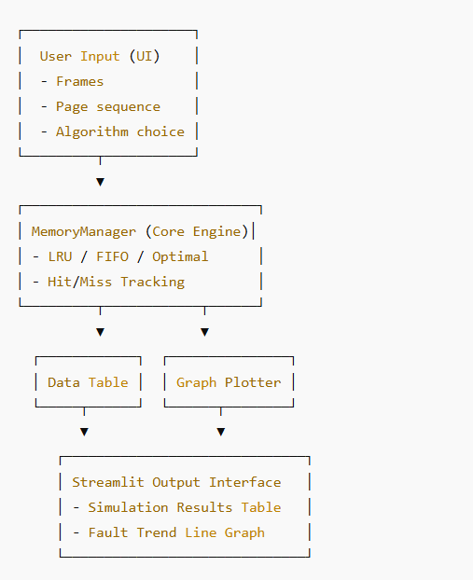

6. Revision Tracking on GitHub
- Repository Name: VirtualMemoryOptimizationChallenge
- GitHub Link: https://github.com/Deepika4321/VirtualMemoryOptimizationChallenge
- GitHub Link: https://github.com/kisu2004/VirtualMemory.py/blob/main/file
This GitHub repository is used for version control, issue tracking, and collaborative updates. It contains:
- Full source code of the project.
- Project documentation and simulation logic.
- Instructions for setting up and running the Streamlit app locally.
7. Conclusion and Future Scope
Conclusion:
The Virtual Memory Optimization Challenge provides an interactive platform to understand and analyze page replacement algorithms including LRU, FIFO, and Optimal. With real-time simulation, tabular tracking, and fault graphs, the tool is effective for both learning and demonstration of operating system concepts.
🔮 Future Scope:
The Virtual Memory Optimization Challenge lays a strong foundation for simulating and visualizing virtual memory behavior. To enhance its impact and usability, the following future improvements can be considered:
- 🆕 Integration of Advanced Algorithms
Extend support to additional page replacement strategies like Clock, Second-Chance, NRU (Not Recently Used), and LFU (Least Frequently Used) to offer a more comprehensive comparison toolkit.
- 📦 Segmentation & Fragmentation Simulation
Introduce modules to simulate segmentation, internal/external fragmentation, and dynamic memory allocation strategies like First Fit, Best Fit, and Worst Fit.
- 📁 File Input & Batch Processing
Allow users to upload reference strings via text files or CSVs for batch simulations, enabling bulk algorithm testing and academic research usage.
- 🌐 Web Deployment & API Integration
Host the application on Streamlit Cloud, Render, or Heroku for public access. Additionally, expose a REST API to allow external applications or educational platforms to use the simulation backend.
- 📊 Comparative Performance Dashboard
Implement a multi-algorithm comparison dashboard with side-by-side graphs, fault counts, and performance ratios to assist students in visual learning.
- 🎯 Adaptive Learning Mode
Build an AI-driven assistant that provides hints, questions, or explanations based on the user’s input—making the tool act like an intelligent tutor.
- 📈 Real-time Analytics & Export Options
Add downloadable reports in PDF or Excel format with charts, stats, and algorithm efficiency summaries for project or academic submission.
- 🎮 Gamified Learning Experience
Transform the simulator into a learning game by scoring users based on prediction of faults or optimal memory usage, encouraging engagement through quizzes and challenges.
8. References
- Silberschatz, A., Galvin, P. B., & Gagne, G. (2018). Operating System Concepts. Wiley.
- TutorialsPoint. (n.d.). Page Replacement Algorithms. https://www.tutorialspoint.com
- Streamlit Documentation – https://docs.streamlit.io
- GeeksforGeeks – Operating System Algorithms – https://www.geeksforgeeks.org
- Matplotlib – https://matplotlib.org
- Javatpoint. (n.d.). Operating System Tutorial. Retrieved from: https://www.javatpoint.com/operating-system
- YouTube – Neso Academy. Operating System Lectures. https://www.youtube.com/@NesoAcademy
- Medium – Understanding Page Replacement Algorithms with Python. Retrieved from: https://medium.com
Code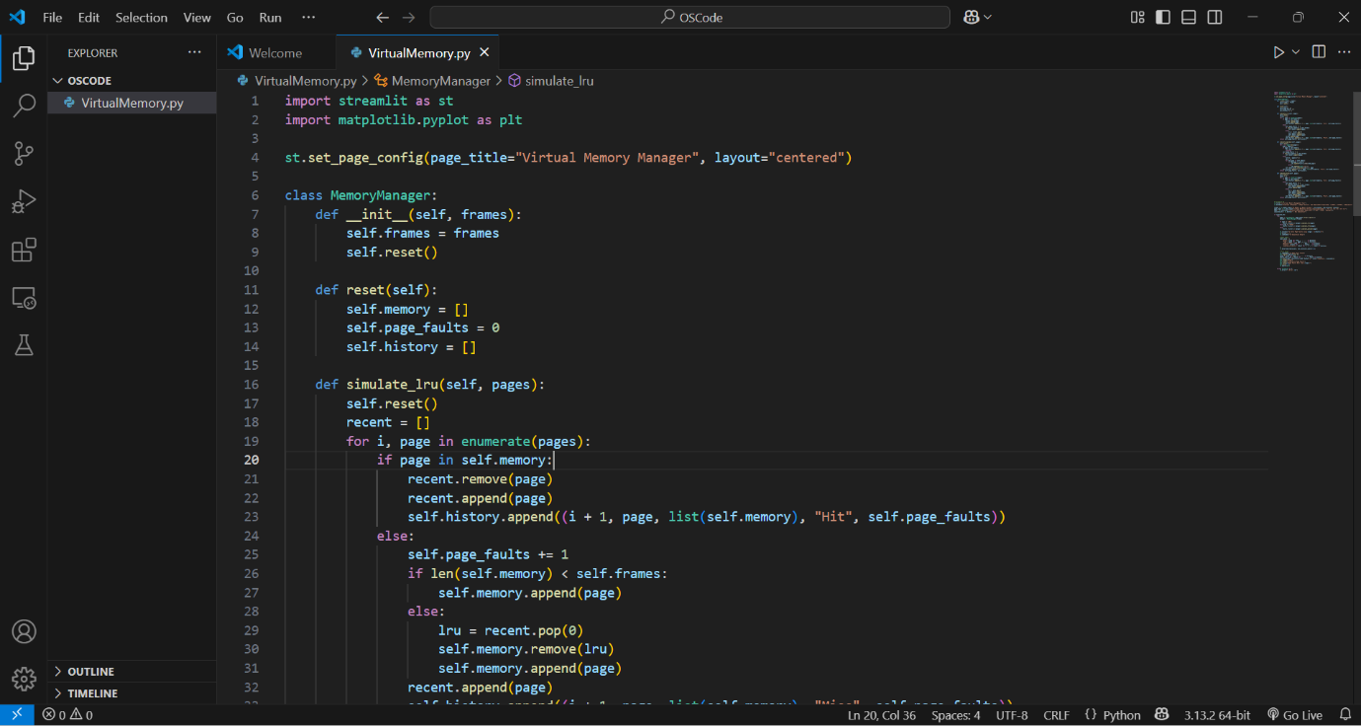
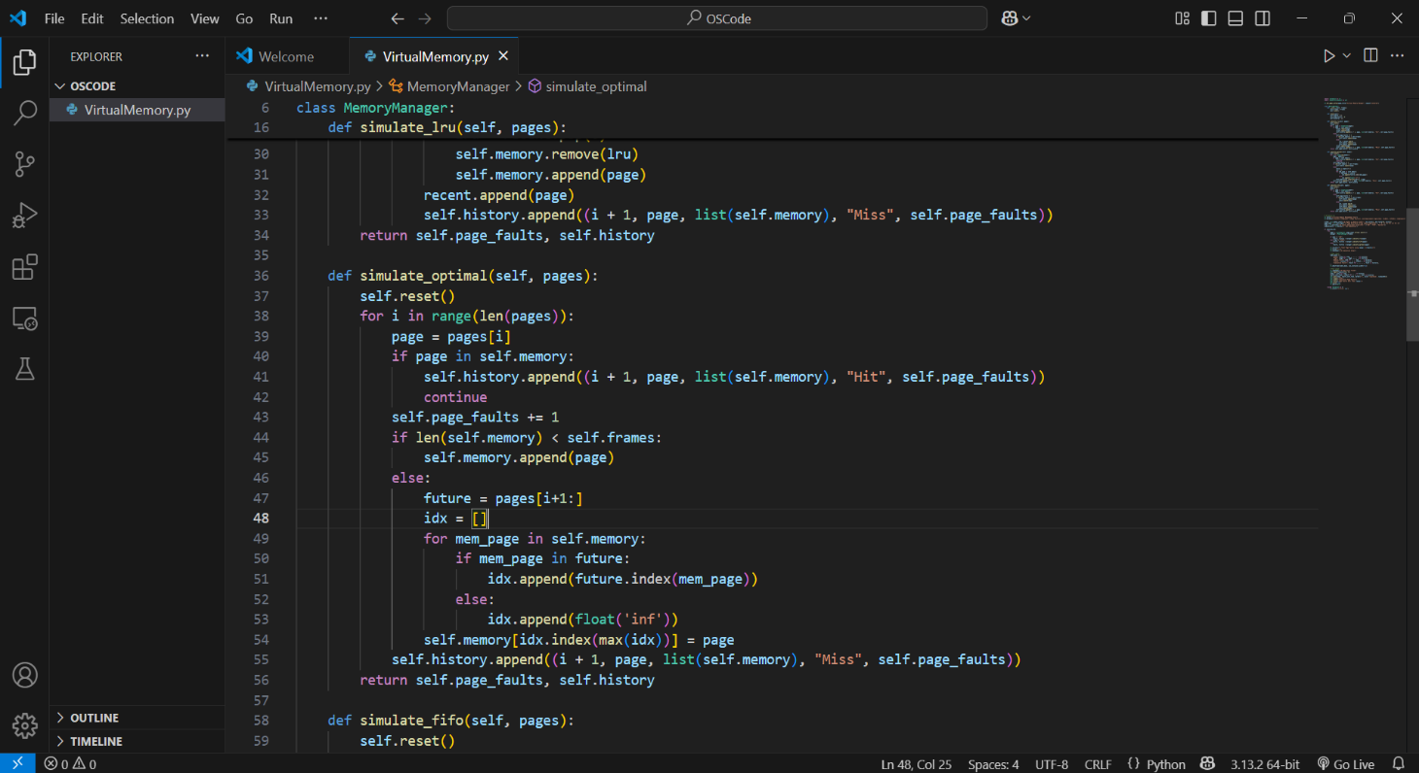

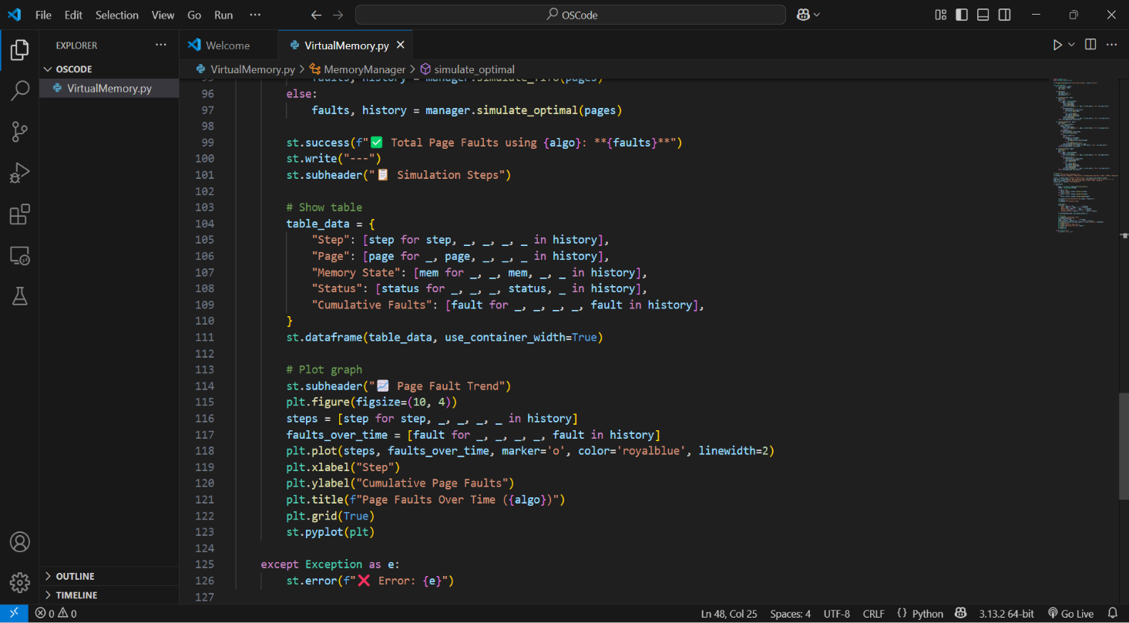

Interface Screenshots: